Sprint - 3

|  |  |
| --- | --- |
| Date | 17 November 2022 |
| Team ID | PNT2022TMID18036 |
| Project Name | Smart Fashion Recommender Application |

**Building a Chatbot:**

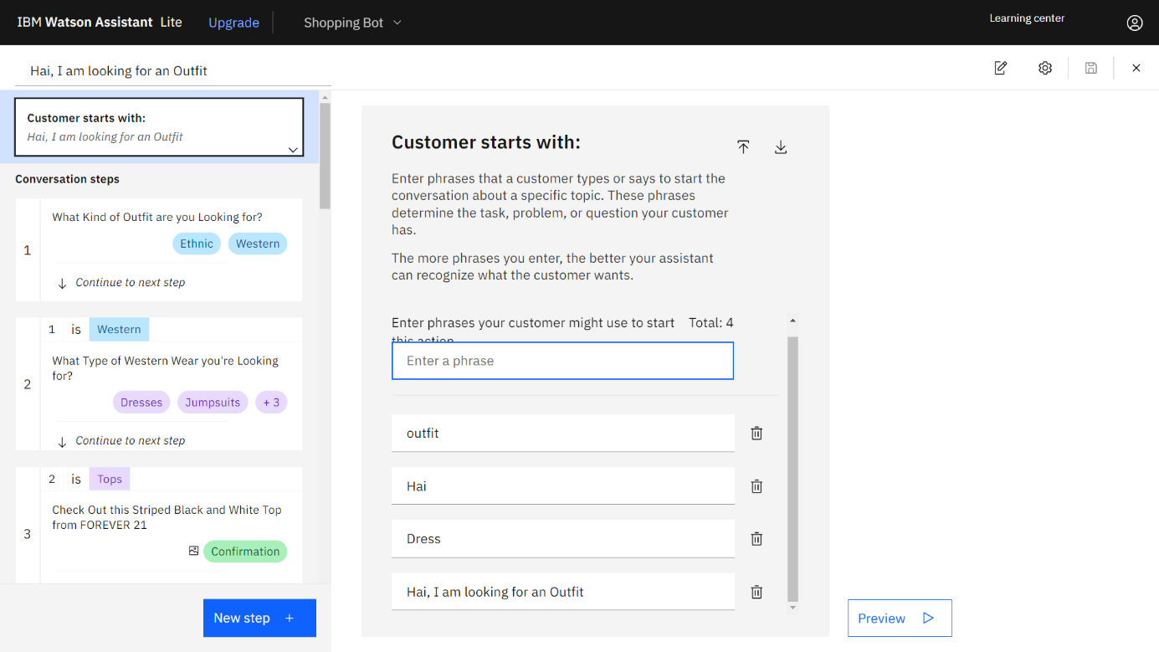

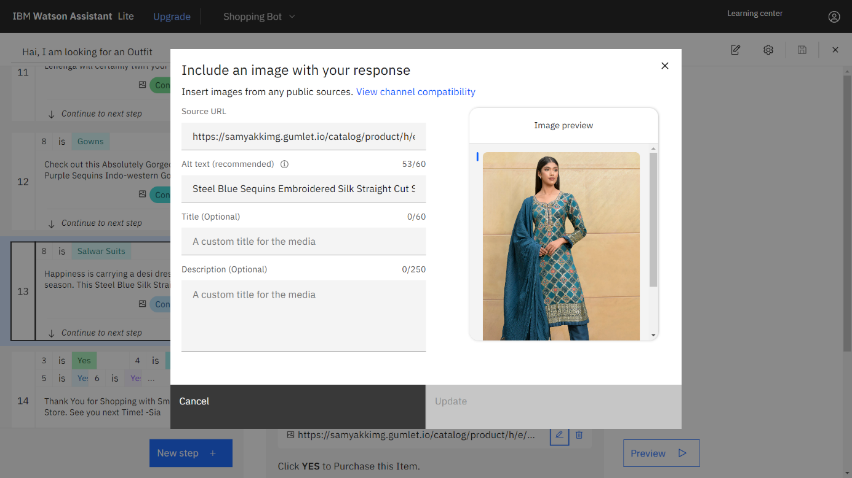

**Chatbot Integration Code:**

<script>

window.watsonAssistantChatOptions = {

integrationID: "3ac3d9ad-d8bf-45d2-a292-1f73a27aceed", // The ID of this integration.

region: "au-syd", // The region your integration is hosted in.

serviceInstanceID: "aafc4048-50e1-4aa2-a877-e2c9d66a1422", // The ID of your service instance.

onLoad: function(instance) { instance.render(); }

};

setTimeout(function(){

const t=document.createElement('script');

t.src="https://web-chat.global.assistant.watson.appdomain.cloud/versions/" + (window.watsonAssistantChatOptions.clientVersion || 'latest') + "/WatsonAssistantChatEntry.js";

document.head.appendChild(t);

});

</script>

**Integrate Chatbot to the HTML Page:**

